**VISVESVARAYA TECHNOLOGICAL UNIVERSITY JNANASANGAMA, BELAGAVI-590 018, KARNATAKA.**



**TECHNICAL SEMINAR REPORT ON**

**“DEMONSTRATION OF HAPTIC TECHNOLOGY, A HANDS-ON APPROACH TO VIRTUAL REALITY”**

*Submitted in the partial fulfilment of requirement for the award of Degree*

**B.E. in Computer Science & Engineering**

**SEMINAR ASSOCIATE**

**SYED FARHAN 4BD20CS104**

**SEMINAR GUIDES:**

**Dr. ARUN KUMAR G HIREMATH Ph.D., Prof. PRIYA V M.Tech.,**

**Assoc. Professor, Asst. Professor,**

**Dept. of CS&E, Dept. of CS&E,**

**B.I.E.T., Davangere B.I.E.T., Davangere**

**Department of Computer Science and Engineering Bapuji Institute of Engineering and Technology Davanagere-577004**

**2023-24**

**Bapuji Institute of Engineering and Technology**



**Davanagere-577004**

**Department of Computer Science and Engineering**

**CERTIFICATE**

This is to certify that **SYED FARHAN** bearing USN **4BD20CS104** of Computer Science and Engineering department have satisfactorily submitted the Technical Seminar report entitled **“DEMONSTRATION OF HAPTIC TECHNOLOGY, A HANDS-ON APPROACH TO VIRTUAL REALITY”** for **TECHNICAL SEMINAR (18CSS84)** in the partial fulfillment of the requirement for the award of Degree of Bachelor of Engineering (B.E.) in Computer Science and Engineering, under the VTU during academic year 2023-2024.

**Dr. Arun Kumar G Hiremath Ph.D., Prof. Priya V M.Tech.,**

**Associate Professor Assistant Professor**

**Seminar Guide Seminar Co-Guide**

**Prof. Rahima B M.Tech., Prof. Madhu N Hiremath M.Tech.,**

**Assistant Professor Assistant Professor**

**Seminar Co-Ordinator Seminar Co-Ordinator**

**Dr. Nirmala C R, Ph.D., Dr. H B Aravind Ph.D.,**

**Head of Department Principal**

**Date:**

**Place: Davangere**

**Vision and Mission of the Department**

**Vision**

“To be a centre-of-excellence by imbibing state-of-the-art technology in the field of Computer Science and Engineering, thereby enabling students to excel professionally and be ethical.”

**Mission**

|  |  |
| --- | --- |
| M1 | Adapting best teaching and learning techniques that cultivates Questioning and  Reasoning culture among the students. |
| M2 | Creating collaborative learning environment that ignites the critical thinking in  students and leading to the innovation. |
| M3 | Establishing Industry Institute relationship to bridge the skill gap and make  them industry ready and relevant. |
| M4 | Mentoring students to be socially responsible by inculcating ethical and moral  values. |

**Program Educational Outcomes (PEOs)**

|  |  |
| --- | --- |
| PEO1 | To apply skills acquired in the discipline of Computer Science and Engineering for solving societal and industrial problems with apt technology intervention. |
| PEO2 | To continue their career in industry/academia or to pursue higher studies and  research. |
| PEO3 | To become successful entrepreneurs, innovators to design and develop software  products and services that meets the societal, technical and business challenges. |
| PEO4 | To work in the diversified environment by acquiring leadership qualities with  effective communication skills accompanied by professional and ethical values. |

**Program Specific Outcomes (PSOs)**

|  |  |
| --- | --- |
| PSO1 | Analyze and develop solutions for problems that are complex in nature by applying  the knowledge acquired from the core subjects of this program. |
| PSO2 | Ability to develop Secure, Scalable, Resilient and distributed applications for  industry and societal requirements. |
| PSO3 | Ability to learn and apply the concepts and construct of emerging technologies like  Artificial Intelligence, Machine learning, Deep learning, Big Data Analytics, IoT, Cloud Computing, etc for any real time problems. |

**ACKNOWLEDGEMENT**

Salutations to our beloved and highly esteemed institute**, “BAPUJI INSTITUTE OF ENGINEERING AND TECHNOLOGY”** for having well qualified staff and lab furnished with necessary equipment’s.

I express my sincere thanks to our guides **Dr. Arun kumar G Hiremath** and **Prof. Priya V** for giving me constant encouragement, support and valuable guidance throughout the course of project without whose stable guidance this seminar would not have been achieved.

I express my sincere thanks to our Seminar Coordinators, **Prof. Rahima B and Prof. Madhu N Hiremath** for their moral support and encouragement.

I express whole hearted gratitude to **Dr. Nirmala C R,** H.O.D of Computer Science and Engineering Department. I wish to thank her for making my task easy by providing her valuable help and encouragement.

I also express my whole hearted gratitude to my principal, **Dr. H B Aravind** for his moral support and encouragement.

I would like to extend my gratitude to all the staff of **Computer Science and Engineering Department** for their help and support. I have benefited a lot from the feedback, suggestions given by them.

**SYED FARHAN (4BD20CS104)**

**ABSTRACT**

Haptics is the science of applying touch (tactile) sensation and control to interact with computer applications. Haptic device gives people a sense of touch with computer generated environments, so that when virtual objects are touched, they seem real and tangible. Haptic technology refers to technology that interfaces the user with a virtual environment via the sense of touch by applying forces, vibrations, and/or motions to the user. This mechanical stimulation may be used to assist in the creation of virtual objects (objects existing only in a computer simulation), for control of such virtual objects, and to enhance the remote control of machines and devices. Haptic Technology promises to have wide reaching applications as it already has in some fields. For example, haptic technology has made it possible to investigate in detail how the human sense of touch works by allowing the creation of carefully controlled haptic virtual objects. Through haptic interface, human can interact with the computer through body sensation and movement. Several applications such as surgical training, gaming etc use haptic technology. Haptic technology has made it possible to investigate in detail how the human sense of touch works by allowing the creation of carefully controlled haptic virtual objects.

**LIST OF FIGURES**

|  |  |  |
| --- | --- | --- |
| **Sl.NO** | **FIGURES** | **Pg.NO** |
| 1 | System Architecture | 01 |
| 2 | Code of Haptic Feedback of Example 1**.** | 10 |
| 3 | Output of Haptic Feedback of Example 1. | 11 |
| 4 | Code in execution of Example 2. | 12 |
| 5 | Output of Simulated Haptic Surgery. | 13 |

**CONTENTS**

**ACKNOWLEDGEMENT** i

**ABSTRACT** ii

**LIST OF FIGURES** iii

**CHAPTERS** **PAGE NO**

1. **INTRODUCTION 01-03**
   1. Description 01
   2. Problem Statement 02
   3. Objectives 02
   4. Existing System 02
   5. Proposed System 03
2. **LITERATURE SURVEY**  **04**
3. **SYSTEM REQUIREMENTS 05** 
   1. Functional Requirements 05
   2. Non-Functional Requirements 05
   3. Hardware Requirements 05
   4. Software Requirements 05
4. **IMPLEMENTATION 06-09**
5. **SNAPSHOTS 10-13**

**CONCLUSION**

**REFERENCES**

**CHAPTER 1**

**INTRODUCTION**

**1.1 Description**

The world haptic is basically invented from the Greek word called "haptikos", which means the sense of touch, and "haptesthai", which meant to touch or make a connection. Humans and machines or combination of both can make the touching process possible. In the recent study the human touch and the force feedback which haptic has begun together biochemicals, psychology, neurology engineering and computer science. Touch is to exchange of the information and the energies between real and virtual environment with respect to user. Active touches the name of given to this type of contact. Haptic technology is tactile feedback to replicate touch by undergoing stress. Aur moment to the respective user.

Human haptics is the use of tactile and kinaesthetic senses for detecting and manipulation. On interacting with an item, skin is subjected to forces. These forces transmit the information and influence how the physical world is perceived. the several mechanical, sensor and motor are basically intellectual components of human textile system are included.  The bodily parts that function according on brain response are included in the mechanical components. Nervous system receptors, which are part of the sense organs, react to physical stimuli by activating and sending information to the brain.

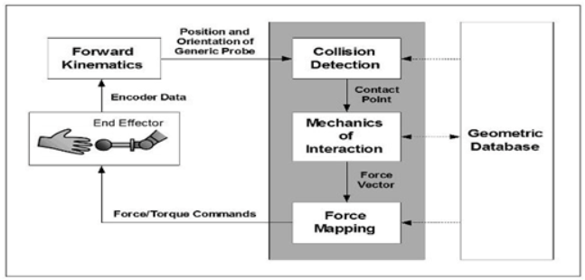**Fig.1:** System Architecture

**1.2 Problem Statement**

Haptic technology offers great potential in a number of industries, including gaming, medical education, and remote operations. It replicates the feeling of touch by imparting stresses, vibrations, or motions to the user. Still, it has a number of difficulties. A limitation of haptic interface design is their low dexterity and small workspace. For example, poor haptic input, diminished depth perception, and impaired hand-eye coordination are common issues faced by surgeons doing Minimally Invasive Surgery (MIS). Three major obstacles to the broad use of haptic devices are their size, battery consumption, and manufacturing cost. The quantity of useful

products that are prepared for the market is constrained by these considerations. There is a lot of potential for innovation and improvement in this fascinating sector.

**1.3 Objectives**

* To develop cost-effective and compact haptic devices.
* To improve the realism and responsiveness of haptic feedback.
* To integrate haptic technology seamlessly with other sensory devices.
* To explore the use of haptic technology in new fields and applications.
* To implement user-friendly interfaces for customizing haptic experiences.

**1.4 Existing System:**

The current haptic technology system is a complicated one that consists of multiple essential parts. Actuators vibrate or apply force to replicate the sensation of touch, while sensors monitor how the user interacts with the haptic device. Control circuitry controls how the sensors and actuators work. Real-time algorithms, sometimes referred to as "players" or "actuator control software," govern how the haptic device behaves in real time. A library of haptic effects offers an assortment of pre-made haptic effects that are adaptable to various applications. Finally, developers can incorporate haptic technology into their own apps with the use of an Application Programming Interface (API). Despite its effectiveness, there are a number of areas where this method might be enhanced and innovated.

**1.5 Proposed System:**

By providing broader tactile sensations, the suggested haptic technology system seeks to go beyond conventional pressure-based interfaces. This cutting-edge device combines a haptic glove with a robotic hand, each with its own set of sensors and actuators. Powered by servomotors, the robotic hand is carefully designed to accurately mimic the complex and complicated motions of the human hand. To control devices within the wireless communication range, the system offers an interactive robotic hand and haptic glove combination. A multimodal feedback system that combines Peltier components and vibration motors guarantees a diverse tactile experience that includes pressure and temperature sensations. The user experience and system dependability are improved by precisely calibrating the accuracy of tactile feedback based on experimental data.

**CHAPTER 2**

**LITERATURE SURVEY**

**Ultrasonic levitation for haptic applications[1]** is a relatively new field with research gaining momentum in recent years. Studies explore generating mid-air tactile sensations by manipulating objects with focused ultrasonic waves. This technology holds promise for creating interactive displays or haptic interfaces without requiring physical contact.

**Haptic gloves with high-fidelity finger feedback[2]** have been an active research area for over two decades. Early work focused on basic vibration motors [Insert early research paper here, while recent advancements explore more sophisticated technologies like McKibben actuators and electrovibration for replicating diverse textures and contact forces [Insert recent research paper here, These gloves aim to enhance the realism and interactivity of virtual and augmented reality experiences.

**Full-body haptic suits for virtual reality[3]** represent an emerging field with research actively growing since the late 2000s. These suits employ various technologies like pneumatic actuators, shape memory alloys, and exoskeletons to provide users with a more immersive experience by simulating forces, vibrations, and pressure across the entire body [Insert recent research paper here (around 2010-2024)]. The research focuses on improving the fidelity of haptic feedback while ensuring user comfort and ease of movement.

**The integration of haptic feedback into everyday devices[4]** like smartphones and laptops has seen a surge in recent years (post-2015). Companies like Apple and Lenovo have incorporated vibration motors and other haptic technologies to enhance user experience by providing tactile cues for button presses, notifications, and other interactions [Insert recent article or press release (around 2015-2024)]. This trend paves the way for developers to create innovative haptic experiences within apps and various applications.

**CHAPTER 3**

**SYSTEM REQUIREMENTS**

* 1. **Functional Requirements:**
* Realistic Feedback
* Low Latency
* High Precision
* User-Friendly Interface
* Integration with Other Systems
  1. **Non-Functional Requirements:**
* Scalability
* Performance
* Security
* Reliability
* Usability
  1. **Hardware Requirements:**
* **Processor:** Intel Core i5 or higher
* **RAM:** 8GB or more
* **Storage Space:** 20GB or more
  1. **Software Requirements:**
* **Operating System:** Windows 7, 8, or 10 (64-bit)
* **Browser:** Google Chrome or Mozilla Firefox
* **Workspace**: Visual Studio code.

**CHAPTER 4**

**IMPLEMENTATION**

**Example1:**

class TextBasedHapticMaze:

    def __init__(self, maze, player_position):

        self.maze = maze

        self.player_position = player_position

    def move(self, direction):

        if self.is_valid_move(direction):

            self.player_position = self.get_new_position(direction)

            print("You moved to a new position.")

        else:

            print("BUMP! You hit a wall.")

    def is_valid_move(self, direction):

        new_position = self.get_new_position(direction)

        # Check if the new position is within the maze and is not a wall

        return (0 <= new_position[0] < len(self.maze) and

                0 <= new_position[1] < len(self.maze[0]) and

                self.maze[new_position[0]][new_position[1]] != 1)

    def get_new_position(self, direction):

        # Get the new position based on the direction of movement

        if direction == 'up':

            return (self.player_position[0] - 1, self.player_position[1])

        elif direction == 'down':

            return (self.player_position[0] + 1, self.player_position[1])

        elif direction == 'left':

            return (self.player_position[0], self.player_position[1] - 1)

        elif direction == 'right':

            return (self.player_position[0], self.player_position[1] + 1)

# Define a simple maze and player position

maze = [[0, 1, 0, 0, 0],

        [0, 1, 0, 1, 0],

        [0, 0, 0, 0, 0],

        [0, 1, 1, 1, 1],

        [0, 0, 0, 0, 0]]

player_position = (0, 0)

# Initialize the game

game = TextBasedHapticMaze(maze, player_position)

# Game loop

while True:

    direction = input("Enter direction (up, down, left, right): ")

    game.move(direction)

**Example2:**

import pygame

# Screen size

screen_width = 800

screen_height = 600

pygame.init()

screen = pygame.display.set_mode((screen_width, screen_height))

pygame.display.set_caption("Simulated Haptic Surgery")

# Background image

background_image = pygame.image.load("ICU-transformed.png").convert()

# Shape (modify for your desired shape)

image = pygame.image.load("1923675-removebg-preview.png").convert_alpha()

# Scalpel position and size

scalpel_x = screen_width // 2

scalpel_y = screen_height // 2

# Define regions with different "textures"

regions = {

    "top": [(0, 0), (screen_width, screen_height // 2)],

    "bottom": [(0, screen_height // 2), (screen_width, screen_height)],

}

# Sound effects to simulate texture

texture_sounds = {

    "top": pygame.mixer.Sound("bomb-countdown-beeps-6868.mp3"),

    "bottom": pygame.mixer.Sound("bleep-41488.mp3"),

}

# Track mouse position

mouse_x, mouse_y = pygame.mouse.get_pos()

current_region = None

current_sound = None

run = True

while run:

    for event in pygame.event.get():

        if event.type == pygame.QUIT:

            run = False

    # Check for intersection between scalpel and region

collision = False

for region_name, region_coords in regions.items():

        region_rect = pygame.Rect(*region_coords)

        if region_rect.collidepoint(mouse_x, mouse_y):

            collision = True

            current_region = region_name

            break

    # Update screen elements based on collision

    screen.blit(background_image, (0, 0))

    if collision:

        # Play sound based on region

        if current_sound != texture_sounds[current_region]:

            if current_sound is not None:  # Check before stopping

                current_sound.stop()

            current_sound = texture_sounds[current_region]

            current_sound.play()

        # Change scalpel color based on texture

    else:

        current_sound = None  # Stop sound if no collision

       # Default white scalpel

    # Draw elements

    screen.blit(image, image.get_rect(center=(scalpel_x, scalpel_y)))

    # Update mouse position

    mouse_x, mouse_y = pygame.mouse.get_pos()

    pygame.display.flip()

pygame.quit()

**CHAPTER 5**

**SNAPSHOTS**

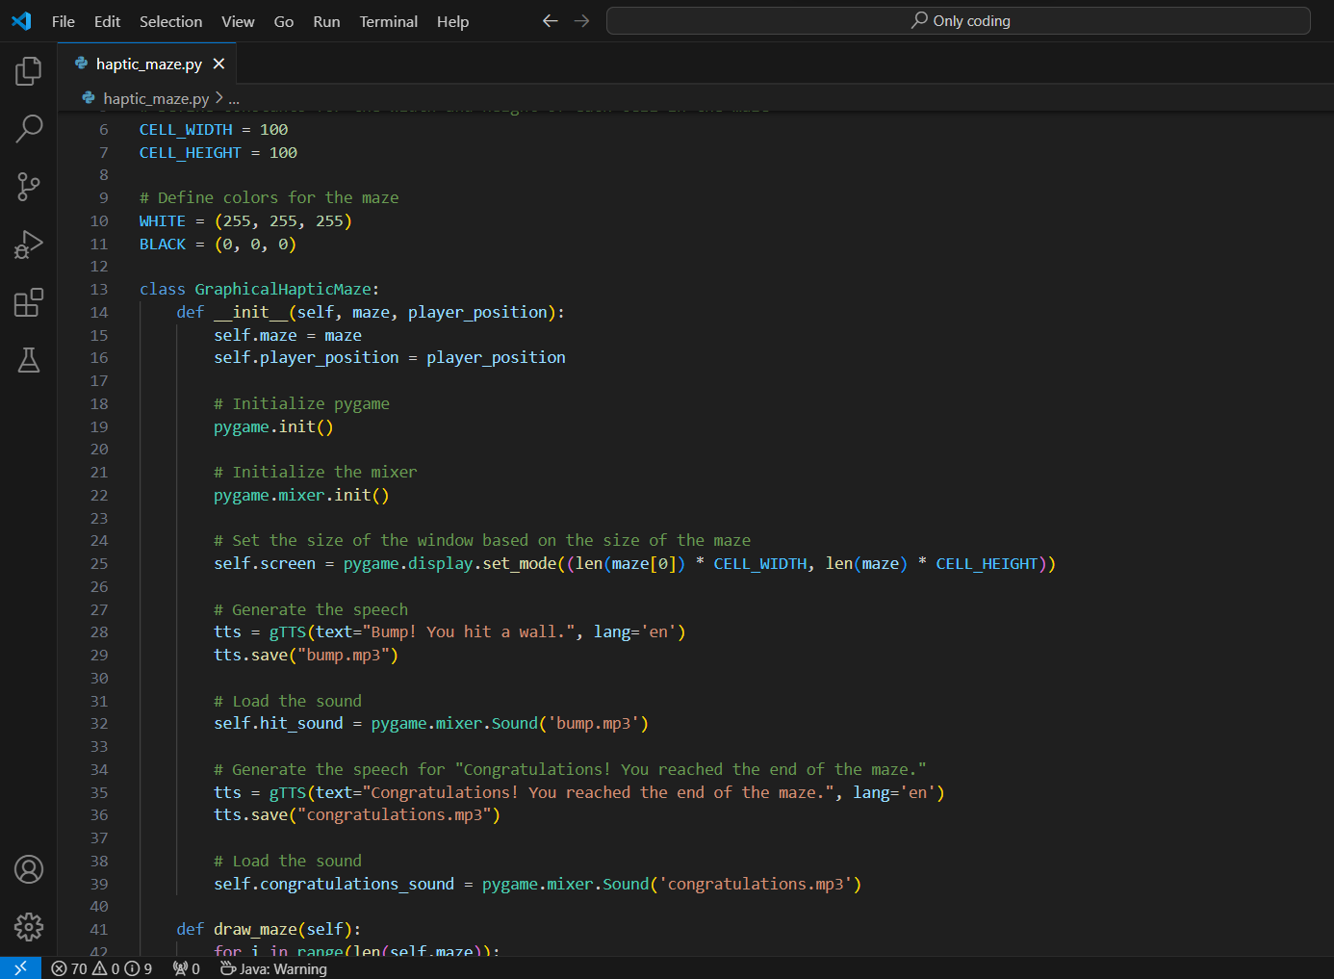

**Fig 2: Code of Haptic Feedback of example 1.**

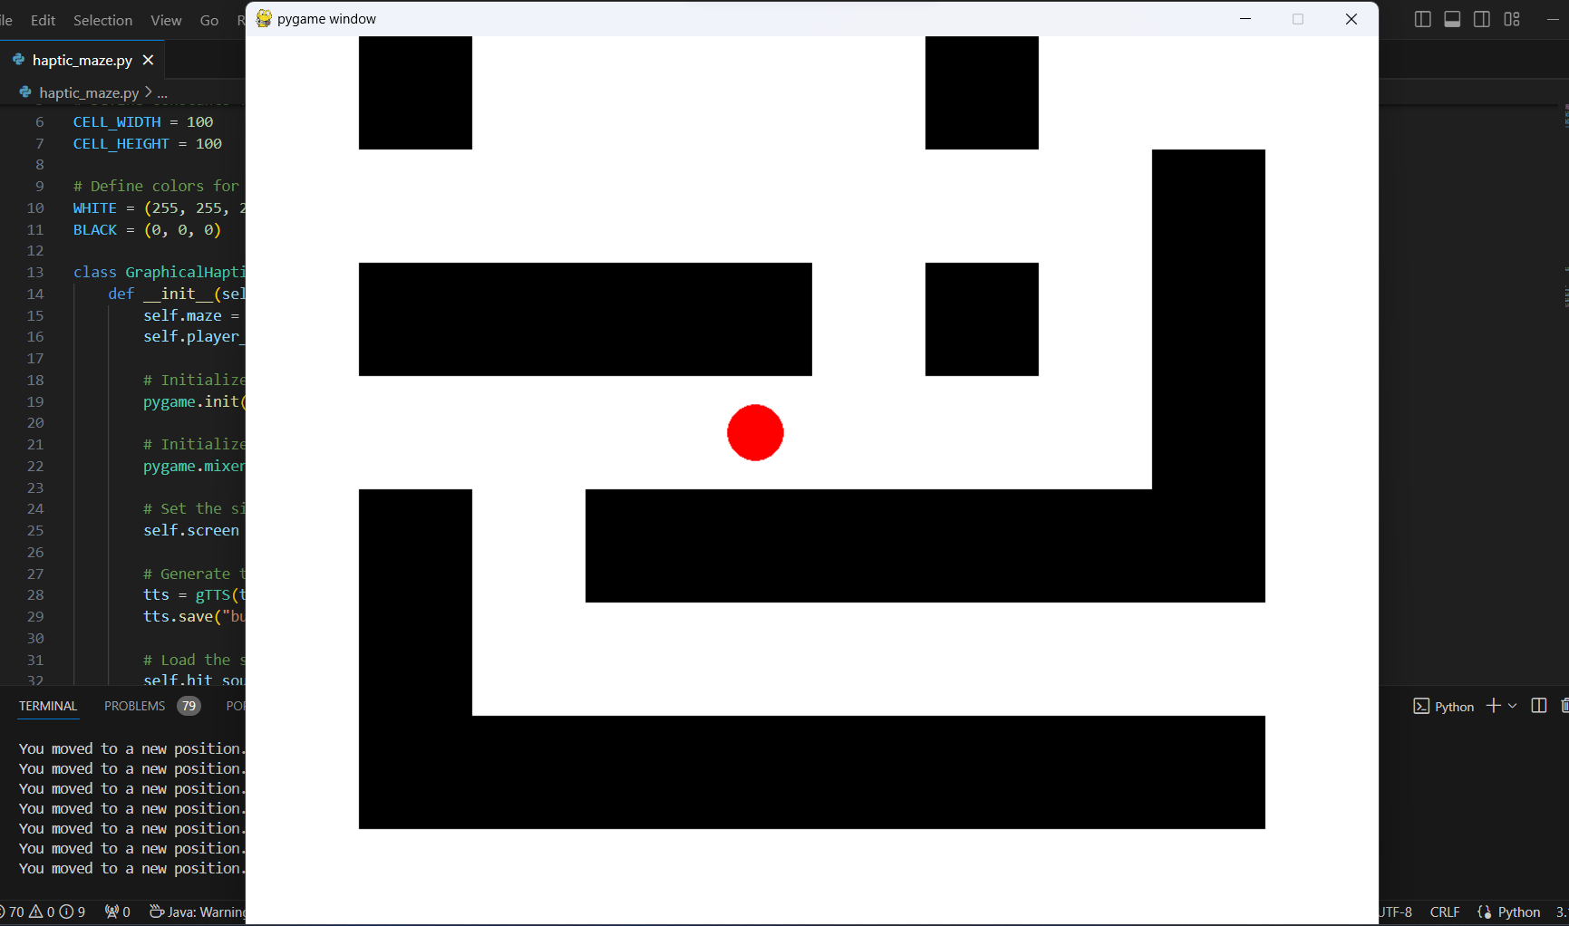

**Fig 3: Output of Haptic Feedback of example 1**

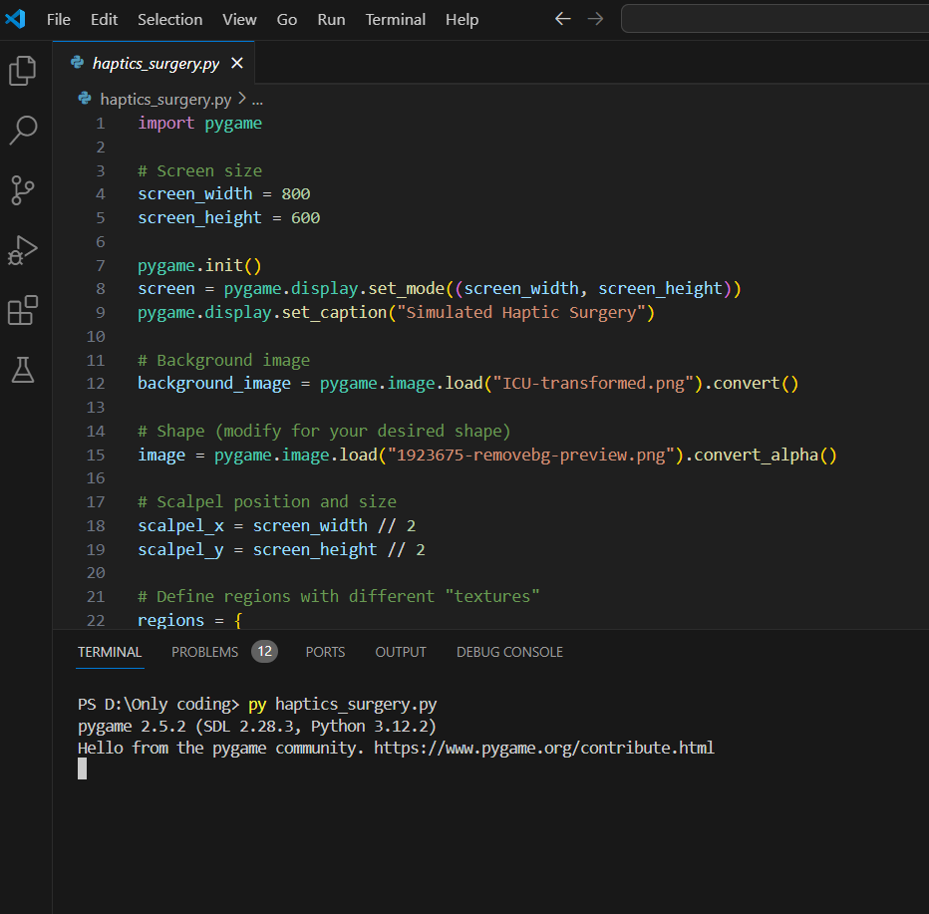

**Fig 3: Code in execution of Example 2**

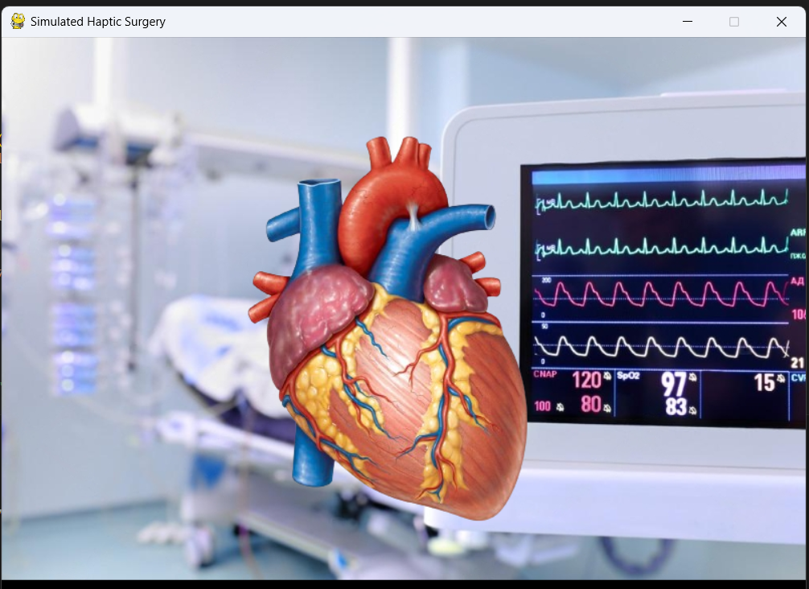

**Fig 4: Output of Simulated Haptic Surgery.**

Two of the most fundamental ways we learn about and interact with our environment are through touch and physical interaction. We think that haptic technology, which is employed in many other areas, is the best approach to engage with a virtual world. The haptic device performs as an input and output device, detecting physical motions of the user as an input and producing lifelike touch experiences as an output, both of which are timed with display events. As technology and computing power improve, haptic devices and effects advance and become more lifelike. Finally, we conclude that haptic technology, which is frequently applied in many applications, is the best method for engaging with a virtual environment. Haptic devices serve as input and output devices, sensing user physical input manipulation and producing a realistic touch output in time with the onscreen event. as technology advances and becomes more practical. technology that can be felt and manipulated. The haptic devices need to be simpler and easier to operate, and this technology needs to be made accessible for a reasonable price.

**REFERENCES**

1. Giri, G. S., Maddahi, Y., & Zareinia, K. (2021). An Application-Based Review of Haptics Technology. [Robotics, 10(1), 29](https://www.mdpi.com/2218-6581/10/1/29)..
2. Haptic Devices: Wearability-Based Taxonomy and Literature Review. [Published in IEEE Access, Volume: 10, Page(s): 91923 - 91947, Date of Publication: 29 August 2022](https://ieeexplore.ieee.org/document/9869830/citations).
3. Haptic Technology - A Sense of Touch. [International Journal of Science and Research (IJSR)3](https://www.ijsr.net/archive/v2i9/MjMwOTEzMDQ=.pdf). [Published in Sensors, Date of Publication: 9 March 2023](https://www.mdpi.com/1424-8220/23/6/2968/review_report).
4. State of art of haptic technology. [The exact publication date is not available, but it was published within the last decade4](https://www.researchgate.net/publication/363103931_Haptic_Devices_Wearability-Based_Taxonomy_and_Literature_Review/fulltext/630e1eb51ddd4470211ea10e/Haptic-Devices-Wearability-Based-Taxonomy-and-Literature-Review.pdf).  [The publication date for the 4th reference, “State of art of haptic technology,” is January 2017](https://www.jetir.org/papers/JETIR1701018.pdf).
5. [“An Overview of Wearable Haptic Technologies and Their Performance” includes papers published between 2015 and October 20223](https://www.mdpi.com/1424-8220/23/3/1563).
6. [The proceedings of the 13th International Conference on Human Haptic Sensing and Touch Enabled Computer Applications (EuroHaptics 2022) took place from May 22–25, 20222](https://link.springer.com/book/10.1007/978-3-031-06249-0).